Associated Papers for the meeting on 9th September 2024
Agenda item
1 Apologies for absence

2 Declarations of interest and
Councillors If there is an item on this agenda for which you have a pecuniary interest you will not be able to take part in any of the discussion or vote on a resolution. However, if you wish the council to consider your request for dispensation you will need to write to the clerk ahead of the meeting stating your reasons on why you should be given a dispensation, or to raise the item now.
.

4 County and District Councillor reports
Current news from both BDC and SCC can be found via the following links:
News » Babergh Mid Suffolk, Council news - Suffolk County Council
5 Planning

c Status of Planning applications
- Discharge of Conditions Application for 4455/16 - Condition 27 (SUDS Asset Register)
Land To The South Of Union Road Onehouse IP14 3EH Aug 2024 Status: Granted
- Householder Application - Erection of single storey rear and first floor side extensions including re-roofing conservatory.58 Ash Road Onehouse Stowmarket Suffolk IP14 3HB
Application. No: DC/24/02697 Status: Awaiting decision
6 Routine Correspondence.
If you wish to discuss an email forwarded that does not appear on the agenda please raise at this point.
There have been a variety of correspondence including:
News letters re
- Public Sector executive
- What’s New in Public Sector Today
- Village Halls and community buildings
- Suffolk Waste Partnership
- SALC local councillor magazine
SALC various updates including training, vacancies
National Grid update
7. Clerk’s Report
Actions from previous meeting
Minute no | Action | Who | Resolved?
24/7/8 | Ask SCC about passing places in Starhouse Lane | Clerk
24/7/16 | Contact Realise Futures to produce laminated sign for Forest Road Noticeboard | Clerk
24/7/19 | Items for future meetings, Clerk recruitment, Onehouse Meadow update, Chilton Leys footpath | Clerk

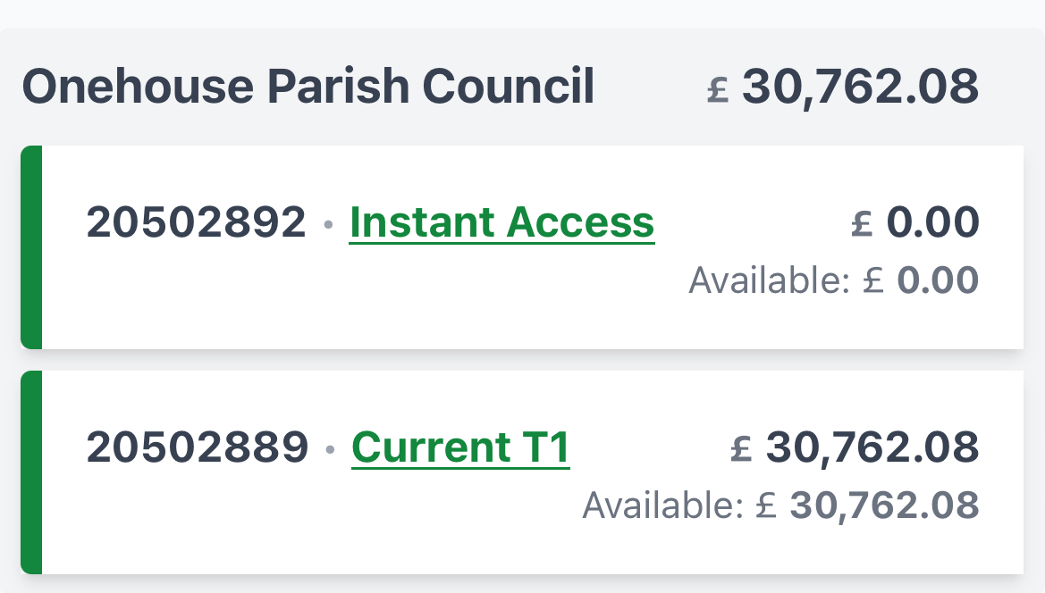
8 Finance Report
Instant Access account £0.00
Current Account £30,762.08
Temporary Clerk respectfully requests a resolution to transfer funds into the deposit account upon receipt of the Precept to enable interest to accrue and leave a small working total in the current account
Payments to be made
£ 145.33 D Nicholson
£39.50 R Taylor
£300 J R Landscapes
Payments paid since the last meeting
£6,541.28

Income Received since previous meeting
£6,322.05
9 Licenced paths, footpaths and assets
10 Recruitment and HR matters
11 Purchase of mobile phone and sim card
12 Benches contractors to repair and produce hand made benches
Plastic Park Bench - Eco Furniture (realisefuturesecofurniture.co.uk) (purchased previously)
Barn Workshop Community Carpenter (tried and tested and very reasonable)
gardenbenches.com
DTaylor Landscapes
14 Training
Councillor development
15 Events

End of Associated Papers

